**Name: OM RAOSAHEB KALE**

**Roll No.: 37025**

**Class: TE IT B**

**Subject: Web Application Development**

**Lab Assignment No. 2 B**

**Title: Create Docker Container Environment (NVIDIA Docker or any other).**

1) Create Dockerfile

Dockerfile

FROM node:alpine

COPY . /docker1

CMD node /docker1/app.js

2) Create app.js

app.js

console.log('Mihika Saraf)

console.log('35063')

3) Run the command to build an image from the docker file

docker build -t docker1 .

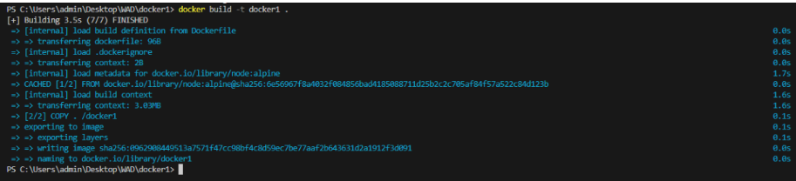

4) Run the command to see the all images

docker images



